
USAGE AND MAINTENANCE MANUAL

ELE

ELECTRIC HOT PLATES
- EKO7010
- EKO7020
- EKO7030
- EKO7010K
- EKO7020K
- EKO7030K
- EKO9010K
- EKO9020K
- EKO9030K

PRESENTATION
DEAR CUSTOMERS,
- To get the best yield of our products that are in compliance with the International Standards, we highly recommend you to read the user’s manual and have it read to your users for long and continuous usages.
- This manual contains important informations about the secure installation, usage and maintenance of the product and necessary remarks to make the most efficient usage of your device.
- Our product is designed for heating and cooking food commodities. Any chemical or liquid substances or similar that can be in contact with the foodstuff, cannot be used for any heat treating that can cause damages for the health.
- The manufacturer cannot be held responsible for any damages from incorrect usage of the device, to people, the environment, or other materials resulting from translation or printing of this booklet.

INDEX

PRESENTATION 2
INDEX 3
SAFETY DETAILS 4
TECHNICAL SPECIFICATIONS 5
TRANSPORTATION, PLACEMENT AND READY TO INSTALL 8
ELECTRICAL CONNECTION 9
USAGE 10
1-) Switching on 10
2-) Switching off 10
CLEANING 11
MAINTENANCE AND MALFUNCTION 11
Problems and Solutions 11
WARRANTY CONDITIONS 12
Out of Warranty Cases 13
AUTHORIZED SERVICE START-UP PAGE 14
Start Up Page 14

sAFETY detaıls
- Do not expose the device to direct sunlight.
- Any kind of flammable or ignitiable solid or liquid such as alchocol and derivaritves, petro-chemical products, wood-plastic materials, curtains, clothes, etc. should not be kept in the area of the device.
- This device must be installed in accordance with the current regulations and should only be used in a well-ventilated area.
- The instructions should be analysed before the installation and the usage of the device.
- It should not be interfered without the presence of the manufacturer or the authorized service.
- The device or its components cannot be used for any other purpose.
- Apart from the heating and the cooking of the food, it cannot be used as a heater for any purpose.
- The device cannot be left uncontrolled as long as it is on.
- Food compatible gloves must be used to protect hands from the overheating.
- In case of fire or flame in the area where the device is, switch off the safety net which is located in the main circuit connection and then use the fire extinguisher. Water should absolutely not be used, otherwise the flame will sprawl faster.
- Before the installation of the device, make sure that the connection rates (frequency, voltage, braker) of the information tag of the device are corresponding with your electrical data.
- Never open the case of the device. The transmition of the electrical connection or the possible contact with the mechanical parts can be dangerous to you and may cause device malfunctions.
- The installation and the maintenance should be carried out by the qualified staff autorized by the manufacturer. Serious danger for the user can be arise due to incorrect installations, maintenances or repairs, and the manufacturer cannot be held responsible.

TECHNICAL SPECITICATIONS
PRODUCT CODE |  |  |  | EKO7010 | EKO7020 | EKO7030 | EKO7010K | EKO7020K | EKO7030K
DIMENSIONS  (mm) | A | WIDTH |  | 400 | 800 | 1200 | 400 | 800 | 1200
DIMENSIONS  (mm) | B | DEPTH |  | 730 | 730 | 730 | 730 | 730 | 730
DIMENSIONS  (mm) | C | HEIGHT |  | 280 | 280 | 280 | 280 | 280 | 280
ELECTRIC POWER |  |  |  | 5,2 kW | 10,4 kW | 15,6 kW | 5,2 kW | 10,4 kW | 15,6 kW
ELECTRIC INLET |  |  |  | 380-400 VAC 3N PE 50 HZ
CABLE CROSS SECTION |  |  |  | 5*2,5 mm | 5*4 mm | 5*4 mm | 5*2,5 mm | 5*4 mm | 5*4 mm
PLATE |  |  | kW | 2,6 | 2,6 | 2,6 | 2,6 | 2,6 | 2,6
 |  |  | Piece | 2 | 4 | 6 | 2 | 4 | 6
WEIGHT |  |  |  | 22 Kg | 45 Kg | 90 Kg | 24 Kg | 45 Kg | 70 Kg

PRODUCT CODE |  |  |  | EKO9010K | EKO9020K | EKO9030K
DIMENSIONS  (mm) | A | WIDTH |  | 400 | 800 | 1200
DIMENSIONS  (mm) | B | DEPTH |  | 900 | 900 | 900
DIMENSIONS  (mm) | C | HEIGHT |  | 280 | 280 | 280
ELECTRIC POWER |  |  |  | 8 kW | 16 kW | 24 kW
ELECTRIC INLET |  |  |  | 380-400 VAC 3N PE 50 HZ
CABLE CROSS SECTION |  |  |  | 5*2,5 mm | 5*4 mm | 5*6 mm
PLATE |  |  | kW | 4 | 4 | 4
 |  |  | Piece | 2 | 4 | 6
WEIGHT |  |  |  | 32 Kg | 59 Kg | 89 Kg

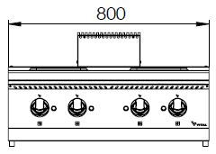
(A)
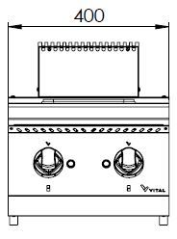
(A)

EKO7010, EKO7010K,
EKO9010, EKO9010K
EKO7020, EKO7020K,
EKO9020, EKO9020K
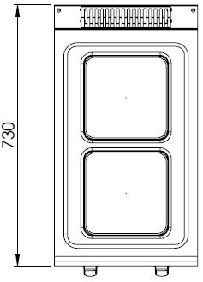
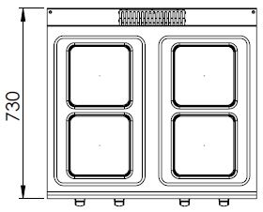
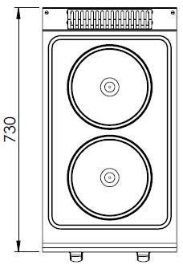

EKO7020K
EKO7010
EKO7010K

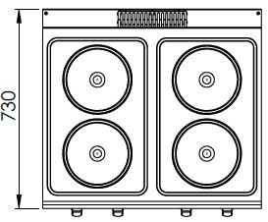
(A)

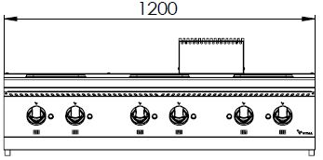

EKO7030, EKO7030K,
EKO9030, EKO9030K
EKO7020

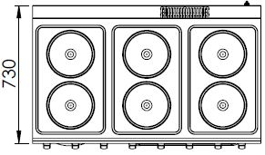
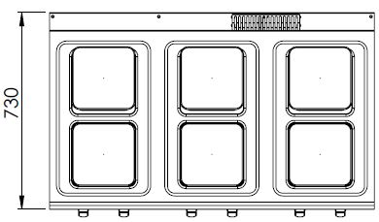

EKO7030K
EKO7030

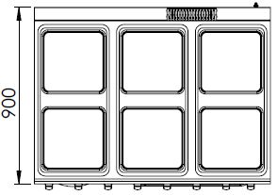
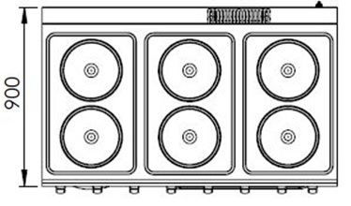

EKO9030
EKO9030K

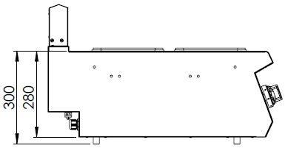

(C)

EKO7010, EKO7020, EKO7030, EKO7010K, EKO7020K, EKO7030K EKO9010K, EKO9020K, EKO9030K

TRANSPORTATION, PLACEMENT AND READY TO INSTALL
- Do not tilt the device during the transportation, carry it upright.
- Use a suitable vehicle to avoid any kind of damages.
- Do not push or drag the device to bear.
- When transporting by pallet jack or forklift, make sure to not damage the device.
- Carry the device with its packaging until the installation area.
- It should be placed under a ventilation system to avoid any kind of bad smell that may occur during cooking process.
- It is recommended to place a suitable sized hood for the ventilation over the device without blocking the outlet of the chimney.
- In case the device is installed next to a wall, a partition, a kitchen furniture etc., make sure they are made by non flammable material or with a suitable thermal insulation coating with a margin of 10 cm, otherwise with a margin of 30 cm.
- Never place a combustible material on top of the device.
- Make a general cleaning before the first usage. You may use soapy water.
- The operating environment and the ventilation system of the device must be between 10°C to 40°C and have a maximum humidity level of %80.
- The device must be installed in accordance within the instructions.
- The protective film on the surface of the device must be stripped off carefully.

ELECTRICAL CONNECTION
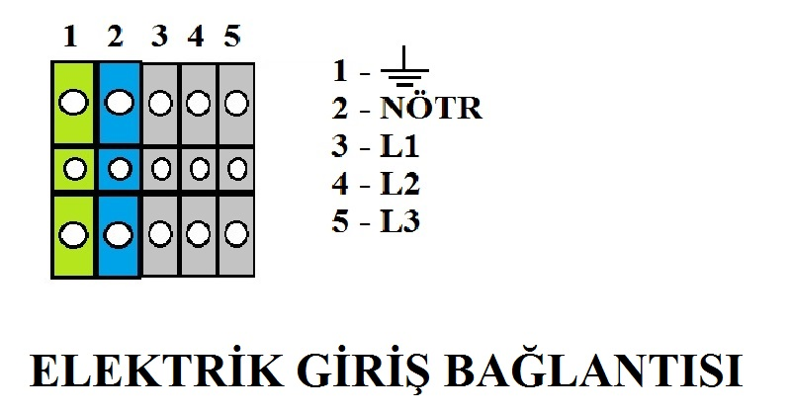
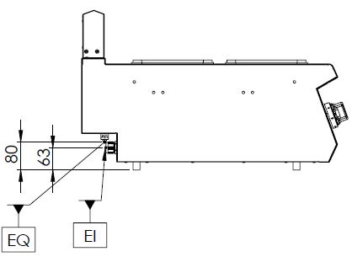
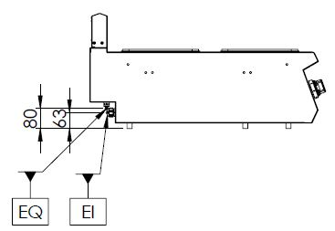

EKO9010K EKO9020K EKO9030K

EKO7010 EKO7020 EKO7030 EKO7010K EKO7020K EKO7030K

EQ=GROUNDING SCREW
EI=ELECTRICAL CONNECTION
- Technical specification section should be analysed for the appropriate cable to be used for the electrical connection of the device.
- The electrical supply circuit must be done by the authorized staff. Before installation, make sure that your fitment meets the requirements. The device should absolutely not be used without grounding.
- The electrical voltage must be stable for the proper fonction of the device. If the malfunction is caused by the voltage, the replacement of these parts are considered “out of warranty”. Fault detection is based on the service declaration.
- To prevent the device from any short circuit and overcurrent, the device must be supplied with the appropriate fuse control.

usage
- The device is designed for professional usage and should only be used by trained personnel.
- If the device is operated as ungear for a while, it will remove the smoke caused by the protective oils.
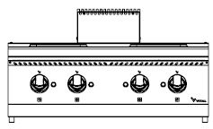
- Appropriate cooking pots should be placed on the device.
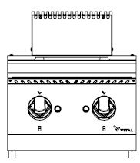

B
B
B
B
A
A
C
C
A
C
A
C
A
B
B
A
C
C

Image - 1 CONTROL PANEL
A | Commutator switch
B | Commutator lamp
C | Section indicator

1-) Switching On
- To power the device, turn on the fuse to which the device is connected.
- Set the commutator switch to the requested level.
- The commutator lamp will be lit and the plates will start to heat up.

2-) Switching Off
- Set the commutator switch to the “0” position.
- The commutator lamp will turn off and the plates will stop heating.
- When the device is not used, turn off the power for your safety.

CLEANING
- Do not wash the device with high pressure water.
- Disconnect the device from the wiring before cleaning.
- After each operation, clean the device with a cloth dipped in warm soapy water.
- Do not use abrasive detergent or wire brushes when cleaning the device’s surface.

MAINTENANCE AND MALFUNCTION
- The maintenance and the malfunction of the device must be carried out by authorized service or by a personnel assigned by the manufacturer.
- All connections and repairs must be carried out by the authorized service centers, otherwise, your device will be out of warranty.

Problems and Solutions
PROBLEM | SOLUTION
Plates do not heat up. | - Check the fuse to which the device is connected.  - Check the commutator switch position.  - If the plates do not heat up after these steps, please contact the AUTHORIZED SERVICE.
The device does not reach the required temperature. | Check the commutator switch of the device. If its at low heat, raise it. If the problem persists after increasing the level, please contact the AUTHORIZED SERVICE.
The device does not turn off. | Make sure that the commutator switch is in position “0”. If it is, please contact the AUTHORIZED SERVICE.

WARRANTY CONDITIONS
- According to the consumer rights law and commercial law of the Ministry of Industry, except in a special case of agreement, sold industrial products by our company has one (1) year of warranty and that period starts from the delivery date of the product.
- The warranty includes all the components of the device against fabrication or faulty workmanship, eliminations of the problems or malfunctions of the device caused by the workmanship and installation errors, replacement of non-repairable parts or the mending of repaired parts that can be reused. It also includes repairings or changes of the components by the authorized personnel, or the labor fee due to the problem under the warranty.
- In order for the warranty conditions to be valid, the maintenance of the components fixed to the device, the maintenance of the product, as indicated in the user’s manual, should be done yearly and montly and the information form must be held after the maintenance to be presented when required.
- The document of the replacement of the component has to be presented for warranty claim parts.
- In order to continue the warranty period, the paid periodic maintenance has to be done by the authorized service and the information form must be held to be presented when required.
- In case of any malfunctions under the warranty period, the time spent in the repairment of the device is added to the warranty period. The repair can be maximum 30 (thirty) days. This period starts when the device is on the service station. In case of the absence of this station, the period will start when the manufacturer or the importer is notified by the product seller.
- In accordance with the regulations of the warranty document implementation fundamentals published by the Ministry of Industry, the warranty deed of the industrial products are the purchase invoices.
- If there is any kind of malfunctions due to both the materail and the workmanship, or assembly faults under the warranty period, the necessary replacement and reparing will be done by our authorized personnel without any charge.

Out of Warranty Cases
- If the product is used above its intended purpose, standards or capacity specified by the manufacturer,
- In case of the bad locationing of the product, continuous usage and unhealthy environment (ex: required ventilation), not suitable floor or flat platform, not using a suitable cable, a proper voltage or a grounding,
- If the product hasn’t been used as explained in the instruction manual,
- If the fault is caused by inconvenient, worng or careless usage,
- If the malfunction is caused by fluactions in the mains power, a stoke or a meteor lightening, a fire, a flood, an earthquake or similar cases,
- If the special tools and equipments installed or the maintenance and repair are made by any other person than the authorized person,
- When requesting a service, if the installation-start documents or purchase invoices of the product are not presented,
- If the informations on the documents of the installation, start or maintenance has been destroyed or changed,
- If the paid annual or the contractual periodic maintenance of the product has not been done on time by the authorized personnel,
- If unoriginal spare parts have been used,
- Notifications to our authorized services under the warranty period about the malfunctions that could not have been repaired, will make the time-out of the warranty stop only for that specific malfunction. In this case, the authorized service will inform about the compensation or the non-troubleshooting and the expanded warranty period will end in 3 months in any cases,
- Damages caused by the unnecessary loss of time, the maleficience, the revenue loss, or the conduction of the product from the defective location to another,
- Malfunctions of the product due to squalidity are not covered by the warranty,
- The methods to be followed about the fault detection and elimination are determied completely by MUTAŞ’s technical service management and the service matter is taken as basis for the determination of the malfunction.

AUTHORIZED SERVICE START-UP PAGE

Start Up Page
- The model and serial number of your device are shown on the “Technical Data” label affixed to the device.
- Select the technical data according to the device model on the nameplate.

MUST BE FILLED BY AUTHORIZED SERVICE!
COMPANY INFORMATIONS | :
PRODUCT | :
MODEL | :
SERIAL NUMBER | :
PRODUCTION DATE | :
SERVICE STAMP AND SIGNATURE | :
PERSONNEL OF THE SERVICE | :
CONTACT
TEL | : 0312 837 76 72
FAX | : 0312 837 73 38
E-MAIL | : teknikservis@vitalmutfak.com

CONTACT


MUTAŞ MUTFAK ISITMA SİSTEMLERİ SAN. PAZ. İNŞ. TUR. İÇ VE DIŞ TİC.LTD.ŞTİ
HEADQUARTER
ADRES: Plevne Cad. No:40 Gülveren / ANKARA

TEL: (0312) 363 99 33 FAX: (0312) 363 94 92

Web: www.vitalmutfak.com E-Mail:info@vitalmutfak.com
MUTAŞ MUTFAK ISITMA SİSTEMLERİ SAN. PAZ. İNŞ. TUR. İÇ VE DIŞ TİC.LTD.ŞTİ
FACTORY
ADRES: Taşpınar Mahallesi Küme Evleri No:154/A Çubuk / ANKARA

TEL: (0312) 837 76 72 FAX: (0312) 837 73 38

Web: www.vitalmutfak.com
E-Mail:teknikservis@vitalmutfak.com

AFTER SALES SERVICE
For the nearest MUTAŞ / VITAL Authorized Service, please contact the numbers above.
teknikservis@vitalmutfak.com

