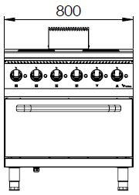

4 SQUARE ELECTRIC HOT PLATE RANGE W/ ELECTRIC OVEN

700'
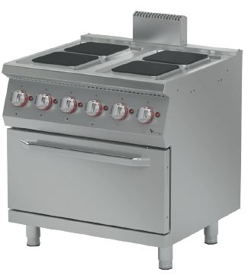
COOKING SERIE

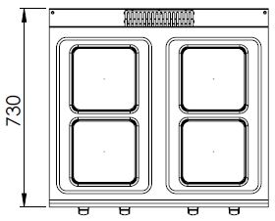

The stainless steel body makes the device durable and enduring.
Easy to clean through its rounded upper surface.
The device is produced with speacial mold and pressed top.
The monoblock worktop increases the durability and ensures an easy cleaning.
The temperature control is made with 6 levels of heating. This allows the user to cook and hold.
The special silicone gasket located on the oven door minimizes heat loss and saves energy.
The special designed resistances located inside the oven provide homogeneous temperature.
The capacity of the oven is 3 x GN 2/1.
The oven temperature is controlled with the thermostat (50-300°C).
220*220 mm 2600W square plates.
The thickness of the upper part is 1,5 mm AISI stainless steel. The body sheets are 1 mm Scoth Brite stainless steel.

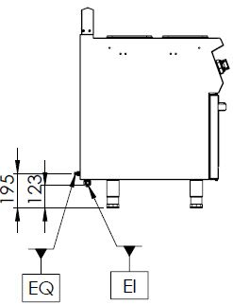

EI=ELECTRIC INLET
EQ=GROUNDING CONNECTION

MODEL | DESCRIPTION | DIMENSIONS | TOTAL POWER | ELECTRIC VOLTAGE /  CABLE CROSS SECTION | WEIGHT
EKF7020K | ELECTRIC RANGE | 800X730X850 | 15,4 kW | 380-400 VAC 3N 50 Hz  /  5X4 mm² | 77 kg net
EKF7020K | ELECTRIC RANGE | 820X800X1050 Package dimension | 15,4 kW | 380-400 VAC 3N 50 Hz  /  5X4 mm² | 92 kg  Gross weight



HEADQUARTER |  | FACTORY
Plevne Caddesi No.40/C |  | Taşpınar Mevkii No.154
Gülveren-Mamak/ANKARA |  | Çubuk/ANKARA
Tel . | +90 312 363 94 93 | Tel . | +90 312 837 76 72
Fax. | +90 312 363 94 92 | Fax. | +90 312 837 73 38
www.mutasgroup.com / info@vitalmutfak.com

