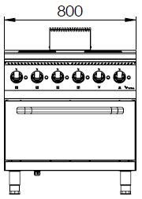

4 ROUND ELECTRIC HOT PLATE WITH ELECTRIC OVEN

700'
COOKING SERIE

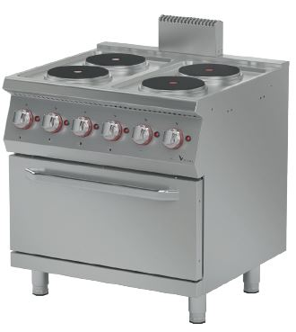

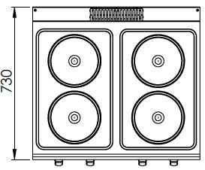

The stainless steel body makes the device durable and enduring.
Easy to clean through rounded corners.
The monoblock worktop increases the durability and ensures an easy cleaning.
The temperature control is made with 6 levels of heating. This allows the user to cook and hold.
The special silicone gasket located on the oven door minimizes heat loss and saves energy.
Special designed resistances provides homogeneous heating inside the oven.
The capacity of the oven is 2 x GN 2/1.
The oven temperature is controlled with the thermostat (50-300°C).
Ø22 diameter 2600W round plates.
The thickness of the upper part is 1,5 mm AISI stainless steel. The coating sheets are 1 mm made of Scotch Brite stainless steel.

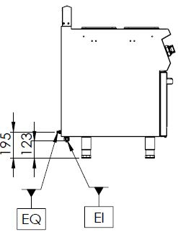

EI=ELECTRIC INLET
EQ=GROUND CONNECTION

MODEL | DESCRIPTION | DIMENSIONS | TOTAL POWER /  MOTOR POWER | ELECTRIC VOLTAGE /  CABLE CROSS SECTION | WEIGHT
EKF7020 | ELECTRIC GAS RANGE WITH OVEN | 800X730X850 | 15,4 kW | 380-400 VAC 3N 50 Hz  /  5X4 mm² | 105 kg net
EKF7020 | ELECTRIC GAS RANGE WITH OVEN | 820X800X1050Package dimension | 15,4 kW | 380-400 VAC 3N 50 Hz  /  5X4 mm² | 120 kg  Gross weight



HEADQUARTER |  | FACTORY
Plevne Caddesi No.40/C |  | Taşpınar Mevkii No.154
Gülveren-Mamak/ANKARA |  | Çubuk/ANKARA
Tel . | +90 312 363 94 93 | Tel . | +90 312 837 76 72
Fax. | +90 312 363 94 92 | Fax. | +90 312 837 73 38
www.mutasgroup.com / info@vitalmutfak.com

