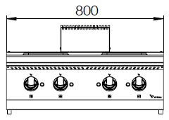

4 ROUND ELECTRIC HOT PLATE

700'
COOKING SERIE

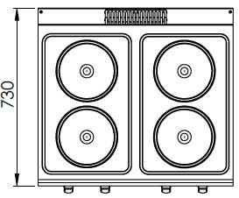

The stainless steel body makes the device durable and enduring.
Easy to clean through its rounded upper surface.
The device is produced with special molds and pressed top.
The monoblock worktop increases the durability and ensures an easy cleaning.
The temperature control of the plates are made with 6 level of heating. This allows the user to cook and hold.
Round plates of 22 cm diameter with 2600 W power
The thickness of the upper part is 1,5 mm AISI stainless steel.
The body sheets are 1 mm Scotch Brite stainless steel.
Can be used on countertop or on base cupboard.

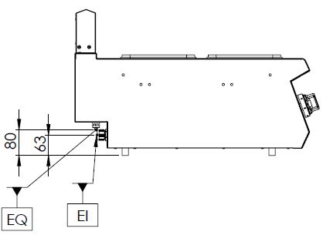

EI=ELECTRIC INLET
EQ=GROUNDING CONNECTION

MODEL | DESCRIPTION | DIMENSIONS | TOTAL POWER | ELECTRIC VOLTAGE / CABLE CROSS SECTION | WEIGHT
EKO7020 | ELECTRIC HOT PLATE | 800X730X280 | 10,4 kW | 380-400 VAC 3N 50 Hz  /  5X4 mm² | 40 kg net
EKO7020 | ELECTRIC HOT PLATE | 820X800X450 Package dimensions | 10,4 kW | 380-400 VAC 3N 50 Hz  /  5X4 mm² | 49 kg  Gross weight



HEADQUARTER |  | FACTORY
Plevne Caddesi No.40/C |  | Taşpınar Mevkii No.154
Gülveren-Mamak/ANKARA |  | Çubuk/ANKARA
Tel . | +90 312 363 94 93 | Tel . | +90 312 837 76 72
Fax. | +90 312 363 94 92 | Fax. | +90 312 837 73 38
www.mutasgroup.com / info@vitalmutfak.com

